Antenna Tester - User Manual

1. Introduction
Welcome to the Antenna Tester application. This software is designed to automate the process of measuring and validating antenna gain across a range of frequencies. It guides the operator through calibration, production order entry, and the testing of individual antenna units, storing all results for traceability.

2. Getting Started

2.1. Logging In
When you first start the application, you will be presented with a login screen.
- Select Username: Choose your username from the drop-down list.
- Enter Password: Type your password into the password field.
- Confirm: Click Ok or press the Enter key to log in.
Note for First Use: The default administrator account is:
- Username: Administrator
- Password: password
It is highly recommended that the Administrator logs in and manages users, creating individual accounts for each operator.

3. Main Test Procedure
The testing process follows a guided workflow. The currently active input field or button will be highlighted with a yellow border to show you where the next action is required.

3.1. Selecting an Antenna
After a successful login, you will see the "Select Antenna for Testing" screen.
- Click on the antenna model you wish to test from the list.
- Click the Select Antenna and Continue button.

3.2. Selecting Orientation and Ports
You will now be on the main testing page.
- Select Orientation: In the "1. Select Jig Orientation" panel, choose either Horizontal or Vertical, depending on how the antenna is mounted in the test jig.
- Confirm Orientation: Click the Confirm Orientation button.
- Select Ports: A dialog box will appear listing all available ports for the chosen orientation. By default, all are checked. Uncheck any ports you wish to exclude from this test run. Click Ok.
- Select Starting Port: From the "2. Select Starting Port" drop-down, choose which of your selected ports you want to begin testing with. Click Start with this Port.

3.3. Initial Calibration (Golden & Silver Samples)
Before testing production units, the system must be calibrated for the selected port. This is required for the first port of a test run or if a port's previous calibration has expired (e.g., after 3 minutes).
- Scan Golden Sample: When prompted by the "3. ... Scan GOLDEN" panel, scan the barcode of the Golden Sample antenna. The system will verify the serial number.
- Start Golden Measurement: When the "4. ... Start GOLDEN Meas." panel appears, place the Golden Sample in the jig and click the Start GOLDEN Measurement button. The system will perform a frequency sweep.
- Scan Silver Sample: When prompted by the "5. ... Scan SILVER" panel, remove the Golden Sample, place the Silver Sample in the jig, and scan its barcode.
- Start Silver Measurement: When the "6. ... Start SILVER Meas." panel appears, click the Start SILVER Measurement button. The system will perform another frequency sweep and compare the results against expected values to verify the entire test setup.
If calibration is successful, the "Port Status" for the current port will change to Calibrated and Verified (Teal color).

3.4. Starting a Production Order
After a successful calibration, you must enter the production order details.
- Enter Order Info: In the "7. Enter Production Order" panel, fill in the following fields:
  - Order Number: The work order or sales order number.
  - Charge Number: The specific batch or charge number.
  - Quantity: The total number of antennas to be tested in this order.
- Confirm Order: Click the Confirm Order button.

3.5. Testing an Antenna (DUT)
You are now ready to test a production antenna, also known as a Device Under Test (DUT).
- Scan Antenna SN: The "8. ... Scan Antenna" panel will appear. The label indicates which unit you are testing (e.g., "1 of 50"). Place the production antenna in the test jig and scan its serial number.
- Start Test: The "9. ... Start Test" panel will appear. Click the Start Test for SN: [serial number] button to begin the measurement.
- View Results: The test will proceed automatically. You can monitor the progress on the progress bar and see the live measurement on the "Antenna Gain vs. Frequency" graph. Upon completion, the result (PASS/FAIL) will be displayed, and a detailed entry will be added to the "Test Results History" table at the bottom.

3.6. Handling Test Failures
If an antenna test FAILS:
- A pop-up window will appear detailing the failure.
- You have two options:
  - Retest Failed Unit: Click this to immediately re-test the same failed unit. This is useful if you suspect a seating or connection issue. This re-test will not count towards your total order quantity. You will be prompted to re-scan the same serial number to confirm.
  - Continue: Click this to accept the failure and move on. The system will prompt you to scan the next antenna.

3.7. Completing a Port's Batch
Once you have tested the required quantity of antennas for the current port (e.g., 50 of 50), the "Order Progress" panel will appear. The status for that port will change to Done (Green color).

3.8. Continuing the Test Run
The "Order Progress" panel gives you three choices for how to proceed:
- TEST NEXT PORT: Click this to continue testing the same production order on a different port. A dialog will appear asking you to choose from the remaining un-tested ports. The system will then initiate the calibration sequence for that new port.
- TEST NEXT ORDER: Click this to start a new production order using the same antenna model and port configuration. You will be taken back to the "Enter Production Order" step.
- FINISH MEASUREMENTS: Click this when all testing for the current antenna model is complete. You will be returned to the "Select Antenna" screen.

4. User Interface Overview

4.1. Main Window Layout
- Left Panel:
  - Active Test Details: Shows the current operator, antenna, order info, and pass/fail counts for the entire order.
  - Port Status: A table showing the status of every available port for the selected orientation. See Appendix for status descriptions.
- Right Panel:
  - Status Display: A large text area at the top showing the current system status and instructions.
  - Input Area: A series of numbered panels that appear sequentially to guide you through the workflow.
  - Antenna Gain Graph: A real-time plot of the measurement.
  - Test Results History: A detailed table of every measurement point for all tests performed.
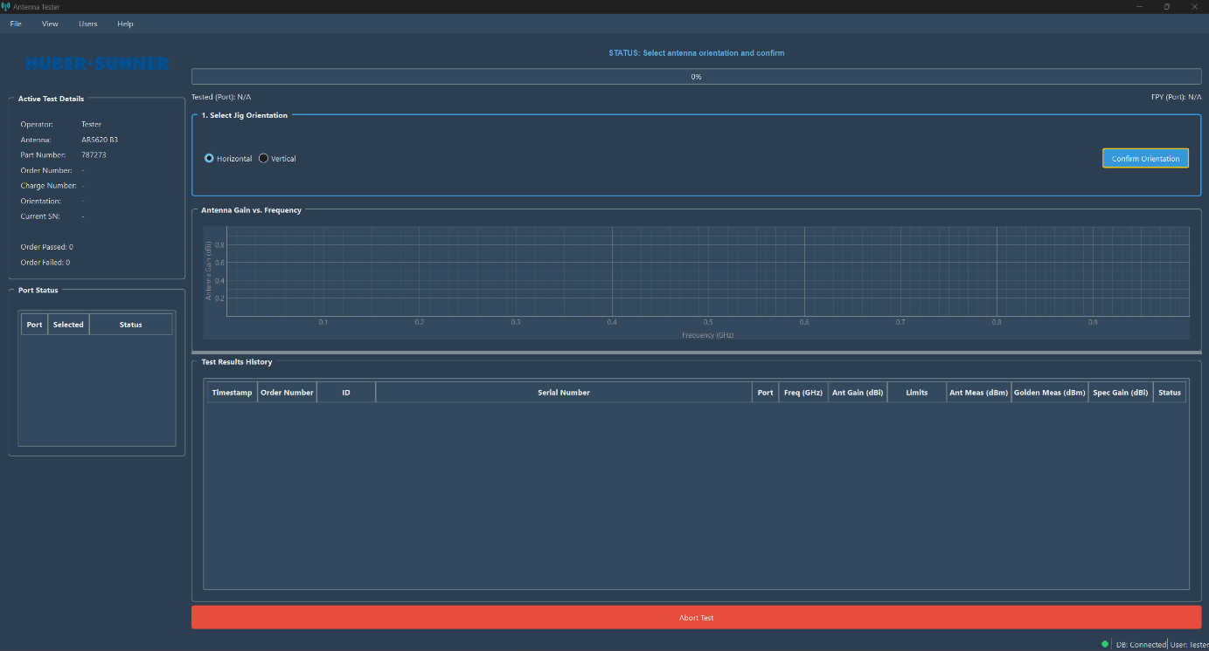
  - Abort Test: A large red button at the bottom. Clicking this will stop any current process and return you to the "Select Antenna" screen. Use with caution.

4.2. Menu Bar
- File > Exit: Closes the application.
- View > Theme: Allows you to switch between Light, Dark, and Auto-detect visual themes.
- Users > Login As Different User...: Allows you to log out and log in as another user without closing the application.
- Users > Manage Users: (Administrator only) Opens the User Management window.
- Help > About: Displays information about the application.

4.3. Status Bar
Located at the very bottom of the window, it shows the database connection status and the currently logged-in user.


5. User Management (Administrator Only)

5.1. Accessing User Management
You must be logged in as the Administrator user. Click on Users > Manage Users from the menu bar.
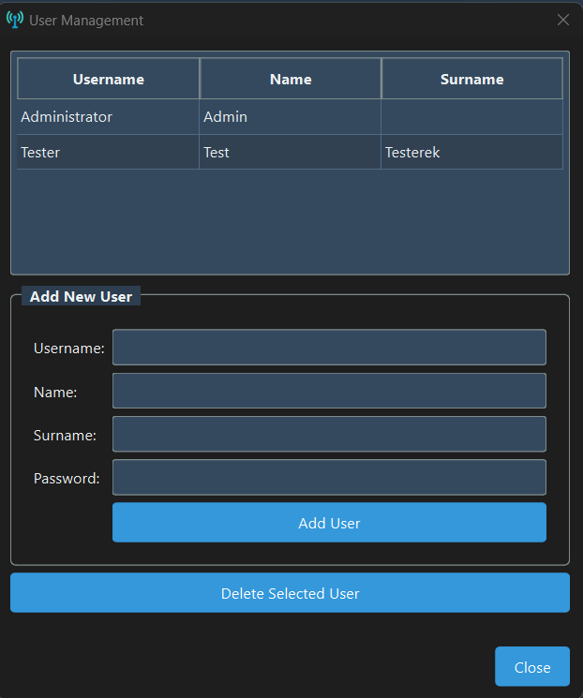

5.2. Adding a User
- In the "Add New User" section, fill in the Username, Name, Surname, and Password.
- Click the Add User button.
- A success or failure message will be displayed at the bottom of the window.

5.3. Deleting a User
- In the user table, click on the row of the user you wish to delete.
- Click the Delete Selected User button.
- A confirmation dialog will appear. Click Yes to permanently delete the user.
Note: The Administrator account cannot be deleted.

6. Appendix: Port Statuses Explained
The "Port Status" table uses text and colors to indicate the state of each port.
- Inactive (Gray): The port is not selected for the current test run.
- Pending (Default/White): The port is selected for testing but has not been processed yet.
- Calibrating (Purple): The port is currently undergoing the Golden or Silver sample calibration process.
- Calibrated and Verified (Teal): The port has passed both Golden and Silver calibration and is ready for production testing.
- Testing (Orange): A production antenna (DUT) is currently being measured on this port.
- Done (Green): The required quantity of antennas for the current order has been successfully tested on this port.
- Cal Failed (Red): The Silver Sample verification failed on this port. Recalibration is required.

